June, 2022

report Rsna ivp – suyash mohan

INTELLIGENCE GATHERING QUESTIONS

Approximately how many radiologists practice in Kazakhstan?
There are approximately 3000 radiologists in KZ.
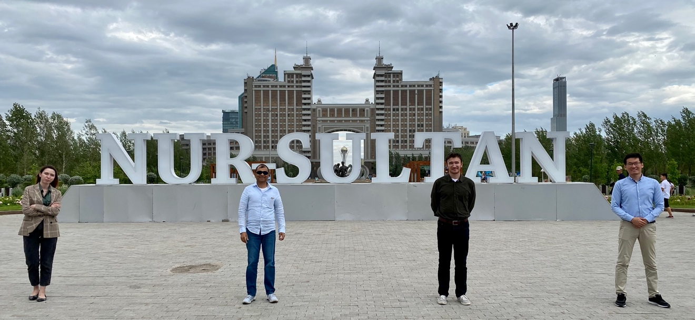
With three of their very bright radiology residents (Bayterek Tower in the background)

What is the ratio of those working in private/public healthcare?
Out of these 3000, approximately half are “ultrasound doctors”, some of these are trained radiologists in other countries and have emigrated to KZ and they can practice as ultrasound doctors, aka ‘super techs’. I met with one of these radiologists from Mongolia, previously worked as a radiologist in Dubai, UAE, relocated to KZ as her husband works for Airbus and is now working in Nur Sultan. She is trying to get her masters now so she can work as a full attending radiologist in KZ.
See photo, 4th from left, and in the 2nd picture.
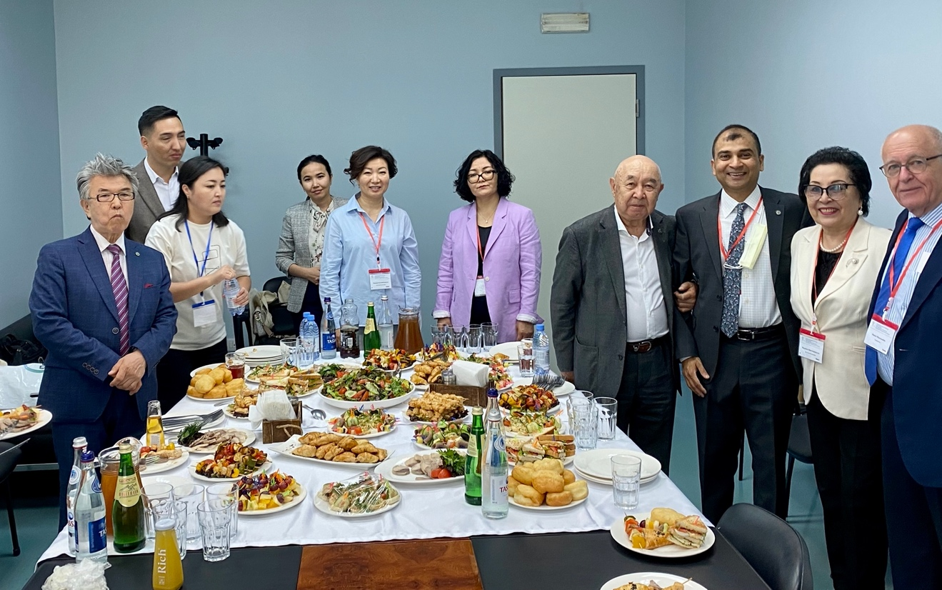
One of the welcome breakfasts on day 1 with department chairs of several other departments
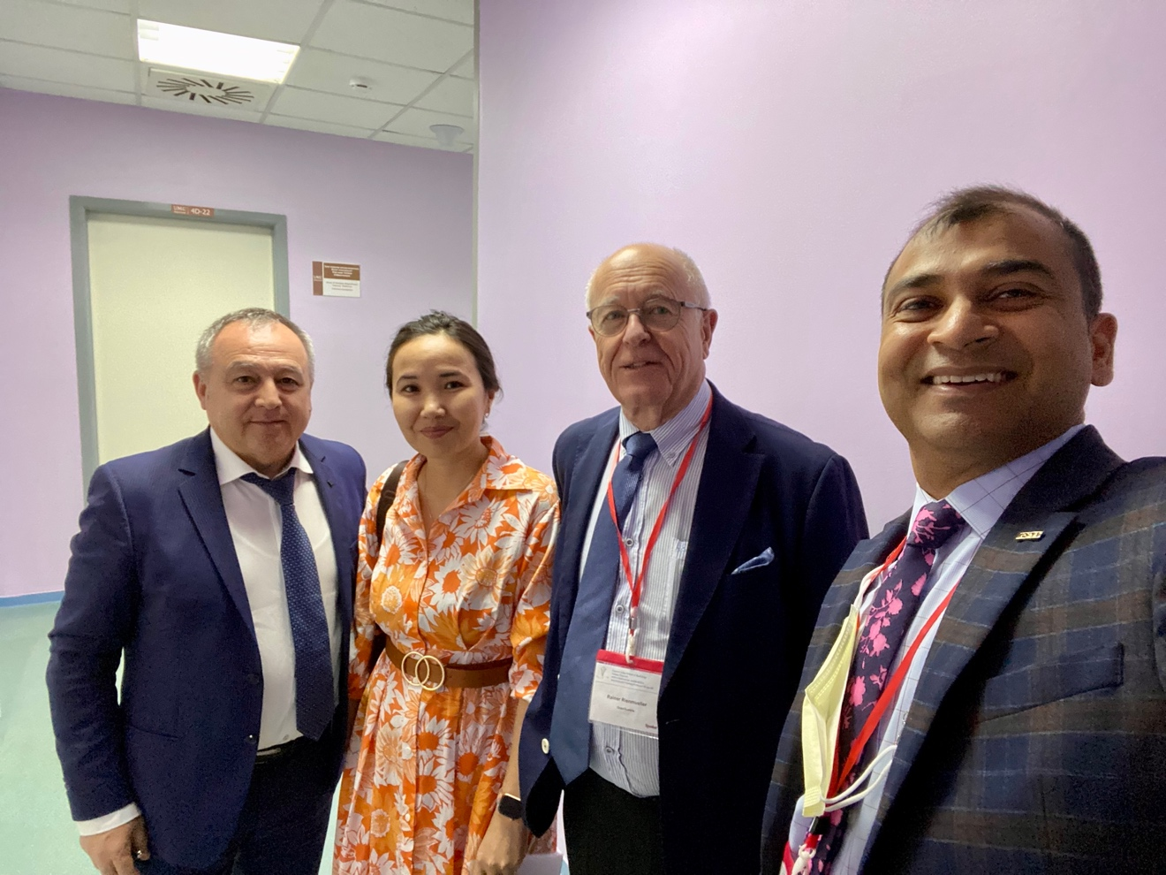
With the ultrasound doctor from Mongolia
Radiology practice is also subdivided based on “who does what”? For example, there are about 700-800 doctors (these are radiologists, but locals call them doctors) who interpret cross sectional studies, CT/MRI, and others just report plain films, so they call them ‘plain film doctors’ and so on.
There are about 14 major cities in the country and generally each one has an academic/teaching institution. Radiology residency is offered in ~10 of these. Some major tertiary care institutions, such as National Neurosurgery Center in the capital city of Nur Sultan, has residencies in Neurology and Neurosurgery but not in Radiology. The largest residency program, and the most prestigious one is in their National Cardiac Surgery Center, home base of our primary contact Dr. Tairkhan Dautov, who is the overall department chair for department of radiology and Nuclear Medicine (also one department, like here in the US). He is also the Vice President of the KZ society of Radiology and is extremely well respected and highly regarded teacher and clinician. The other interesting thing is the Department of Radiology is subdivided into –
Department of Diagnostic Radiology (mostly outpatient based)
Department of Interventional Radiology
Department of Nuclear Radiology
Department of Ultrasonography
Department of Inpatient Radiology
This is like us having multiple divisions/subspecialties like, MSK, Neuro etc.

See photos:
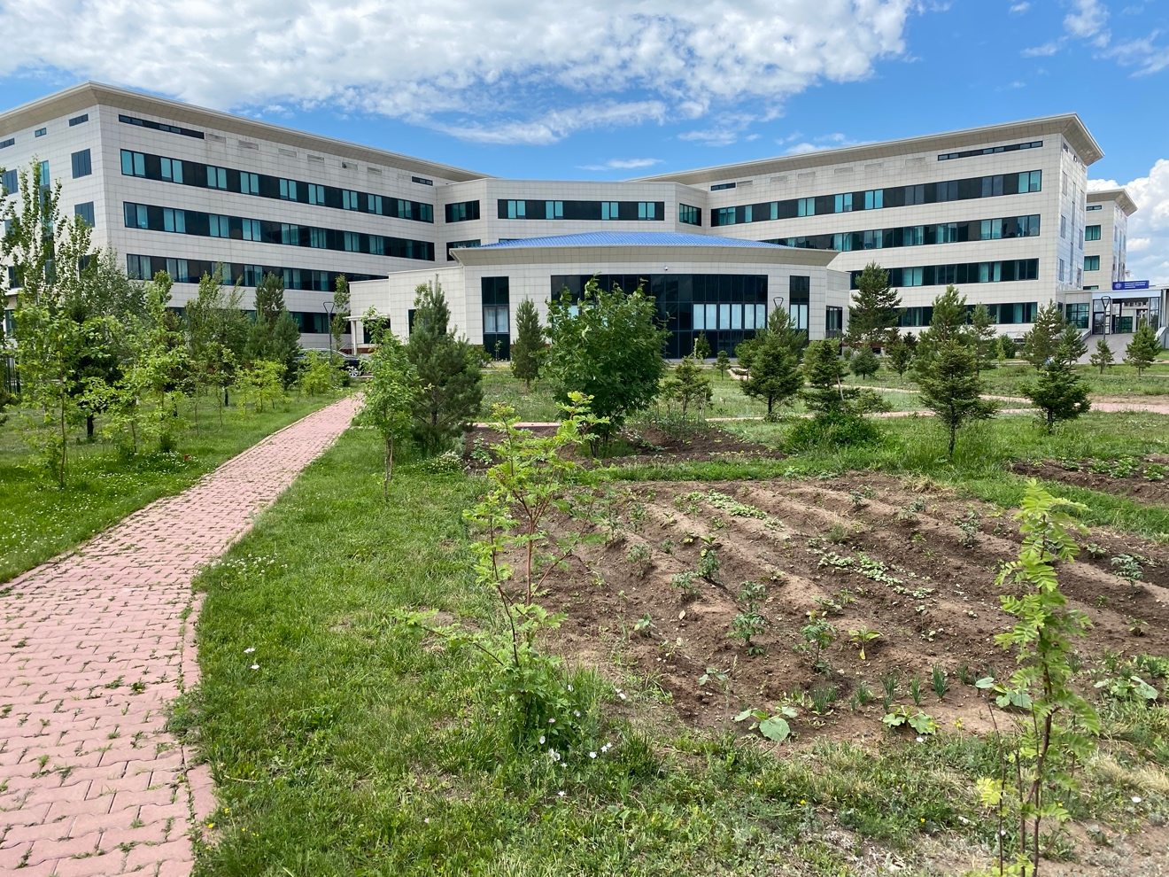
National Cardiac Surgery Center (from the back of the building).

The garden in front is maintained by the hospital staff. Sometimes residents are sent here to work, as a form of punishment. It is primarily maintained by the Director of this center who is a very famous cardiac surgeon in central Asia, Dr. Yury Pya, who is seen walking around during the day after his surgeries working in the garden.

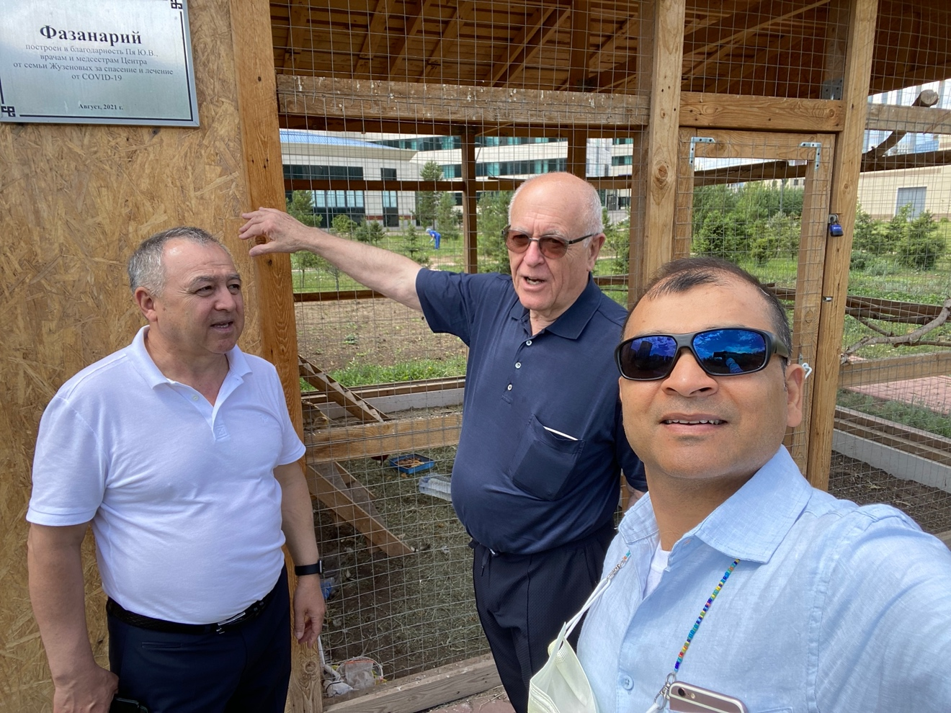
Dr. Dautov showing us the garden on Day 1 with Prof. Reinmueller, chair of radiology at Graz, Austria, another visiting expert cardiovascular radiologist.
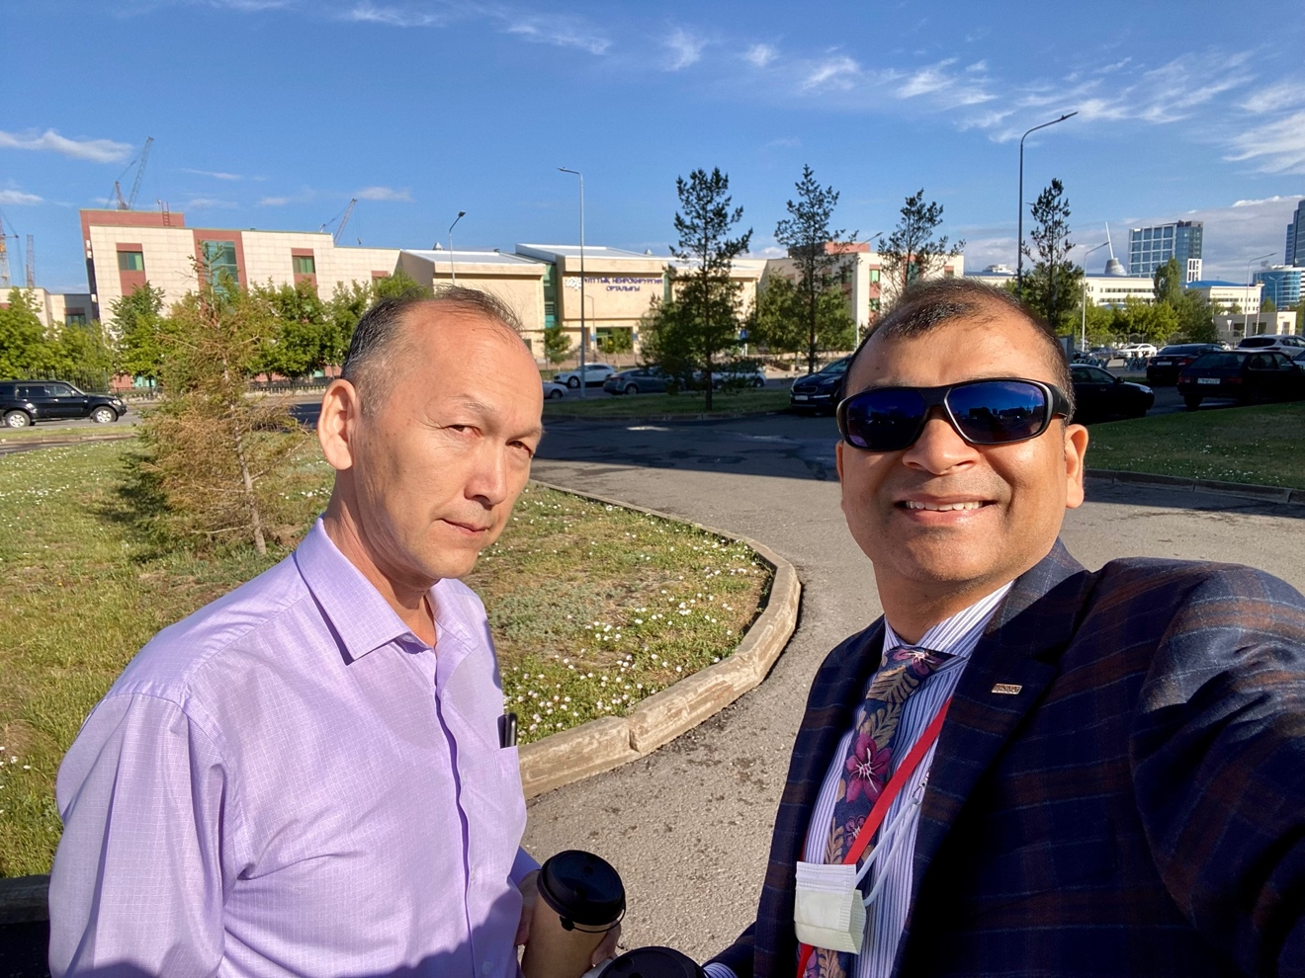
National Neurosurgery Center, with Dr. Zhanibek Baiturlin, chair of the department of radiology, one of the few neuroradiologists in the region.

What are the major issues facing radiologists in Kazakhstan?
There are several.

The most important ‘issue’ that stood out to me was that the radiology residents are not paid any stipend at all. Over 90% residents will do a 11-12 hour shift everyday M-F, Saturdays being half days. Instead of getting paid, they have to pay a tuition fee every year which is ~$3000.00-$3500.00 per year for a 2-year residency. A small number of residents will get scholarship (they call it ‘grants’) which is 90,000.00 Tenge per month which is ~ $ 200.00 per month, which is not even enough to pay for monthly rent of a 1-bedroom apartment, ranges from $400-600 per month.

The second issue is also related to remuneration, the junior attending radiologists are significantly underpaid! For example, first academic job just out of residency will pay ~ $500.00 per month. Compare this with a manager/mid-level post in a construction company who will make ~ 2500.00 per month (I spoke with a local guy who works in one such local company). The pay of the radiologist obviously increases with experience and number of years but even at the most senior level it is ~ $5000-7000 per month, much less compared with other clinical specialties. Note, the local income tax for this bracket is ~ 25-27%. Granted overall cost of living is not as much but still the discrepancy in pay was striking!

The next major issue facing the radiologists in Kazakhstan is lack of subspecialty training. Radiology residency is only two years, some after finishing their residency will move into private practice, some will take up jobs as ultrasound doctors (and make a lot more money, upwards of 200,000.00 Tenge per day), some will choose to interpret cross sectional imaging, in either private radiology clinics, teleradiology jobs or some academic jobs, many will even do upto three jobs to earn more money. Some will decide to do an additional masters course in radiology which is of two years (to gain more experience) and very few who are determined to go into academics we do a Ph.D. afterwards which might take anywhere between three to four years. Most residents and trainees do realize that two years of residency is not enough for getting adequately trained in all the 18 subspecialties of radiology which has now obviously become very advanced. Residents and even attending doctors also realize that two years of training is not adequate in preparing a resident for practice and they are encouraging many of their trainees to seek additional training at higher centers which has traditionally been in major Russian cities such as Moscow, given that Russian is the most preferred language used in daily communication as well as for the practice of medicine, in patient charts/EMR and even for creating radiology reports, next most commonly used language is Kazakh. Some of their tertiary care referral centers such as National Neurosurgery Center do offer advanced subspecialty training in other disciplines such as neurology, neurosurgery etc but the radiologists who are practicing even in these centers are not subspecialty trained, and tertiary care centers do not offer any kind of advanced training in neuroradiology. However, they are realizing the need for more specialized training given increasing demands from their clinical colleagues who are highly trained and are demanding advanced MRI techniques such as fiber tractography, functional MRI for pre-surgical mapping and post operatively MR perfusion, MR spectroscopy etc, for longitudinal response assessment in brain tumors.

Courses and IVP program such as this one were very well received as they were able to get practical tips on several of these advanced techniques and learn the nuances with exposure to what is being currently practiced at tertiary care centers in North America.

See photo: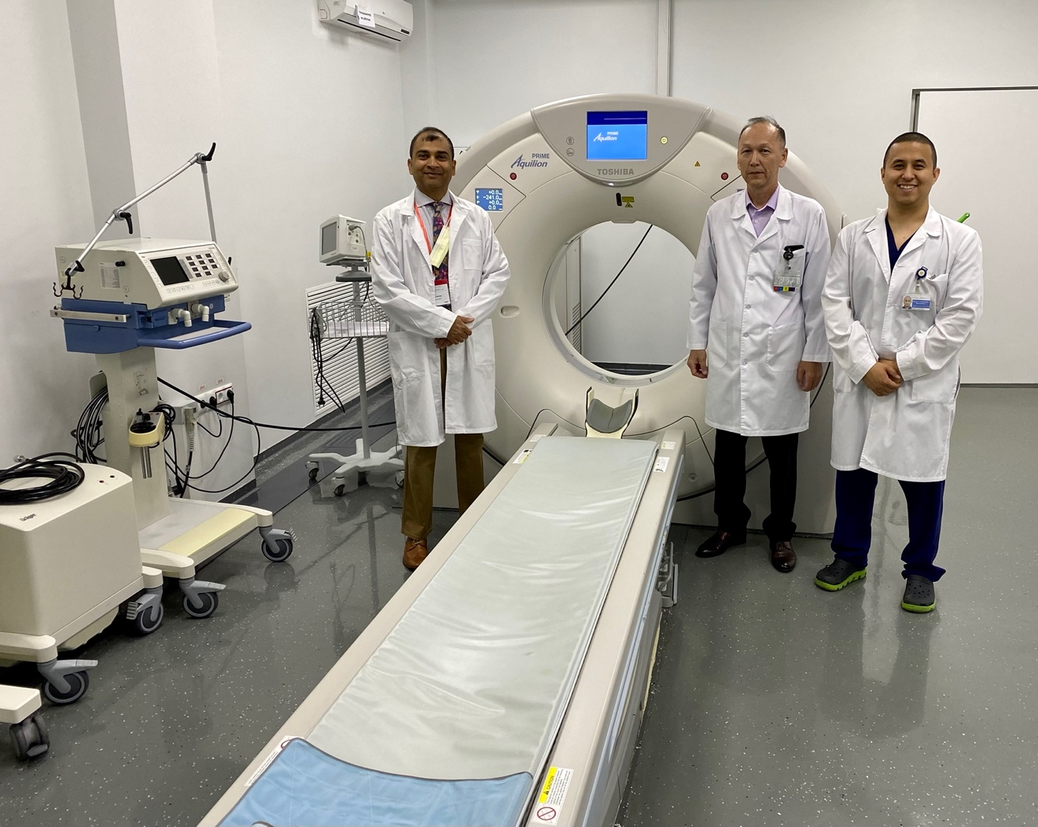

Visiting National Neurosurgery Center, Toshiba 256 slice CT scanner

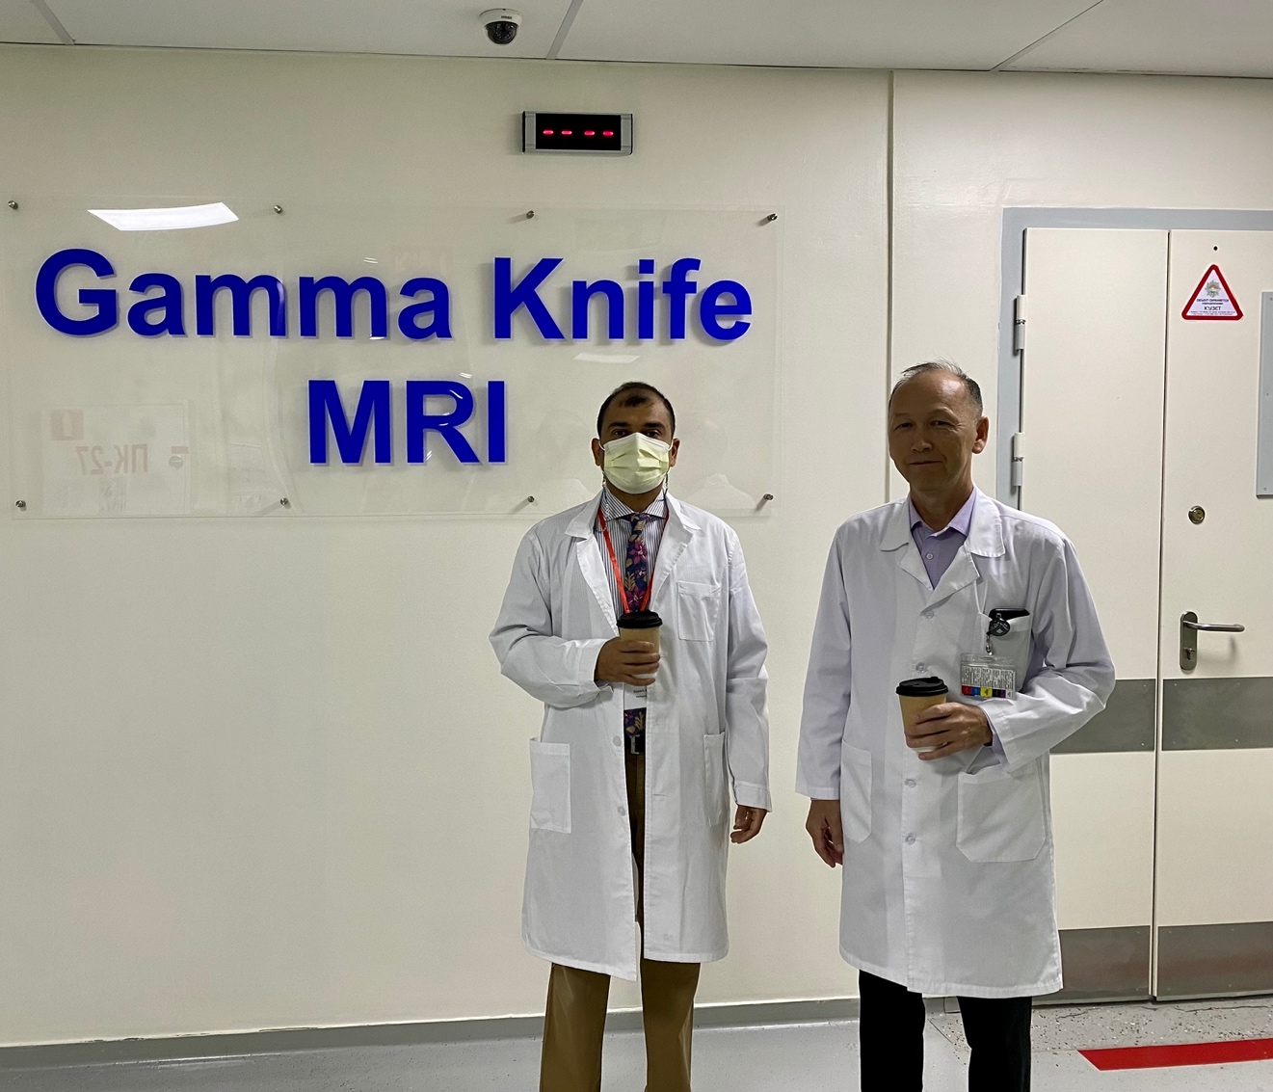

The only gamma knife center in the region

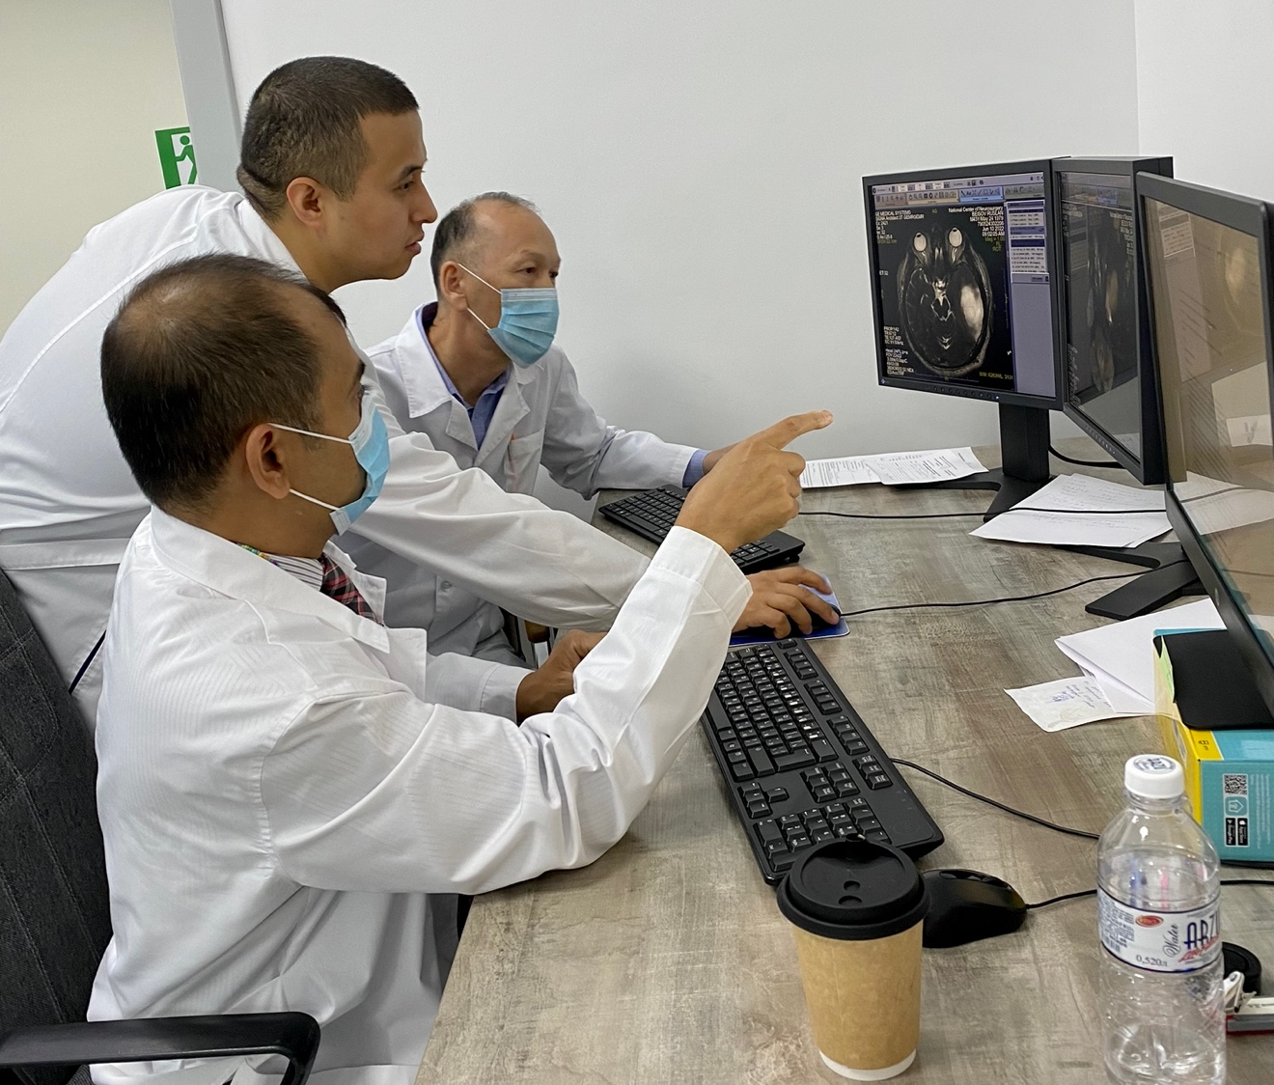

Hands on workshop with their junior attending Dr. Daulty, reviewing a brain tumor case.

The senior leadership including dean of the medical school, department chairs, senior leaders in the KZ society of radiology are all recognizing this deficiency and are working to change the residency structure as per ACGME standards and converting to 4 years with 4th year dedicated for mini-fellowships, as in the US. I met with the Dean of the medical school and emphasized on these points which hopefully will be implemented in near future and will help in improving the overall standard of training in the country.

The next issue is lack of subspecialty practice, even in the national cardiac surgery center I saw occasionally patients with ‘non-cardiac’ conditions, showing up, and will get their imaging performed, e.g., I saw a patient with pituitary adenoma, pregnant females with eclampsia etc.. Another such example that I noticed was an acute stroke patient showed up at ‘mother and child hospital’.

I met with the department chairs and chiefs of radiology at these hospitals and encouraged them to create an informal sub-specialization (as an alternative stop=gap arrangement) within their respective departments where individual radiologist will be encouraged to get additional training (and will be allowed to practice) in the subspecialty of their interest while everyone will share the load of plain films, US and common imaging examinations by rotation.

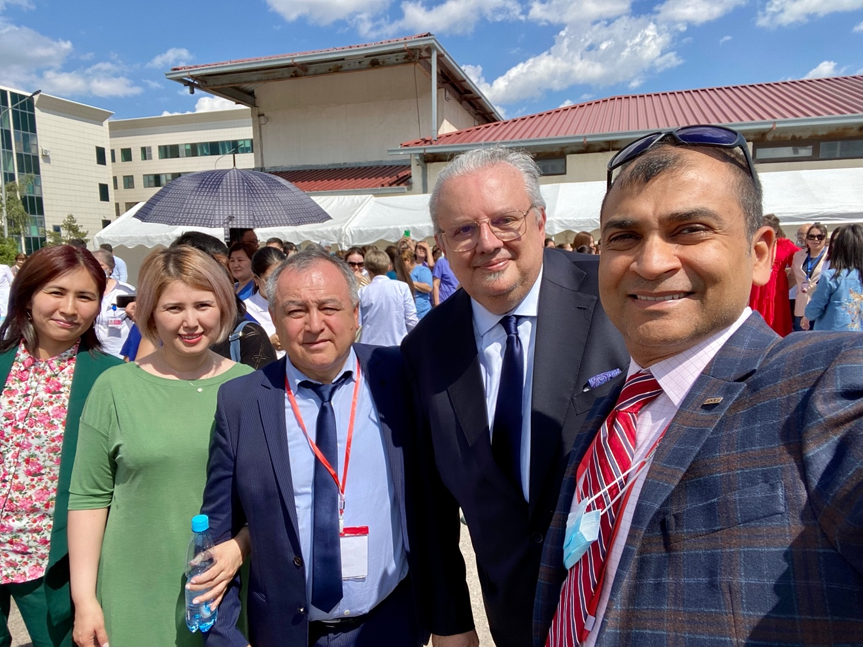

With the Dean of the medical school, Dr. Pignatelli, GI pathologist by training.

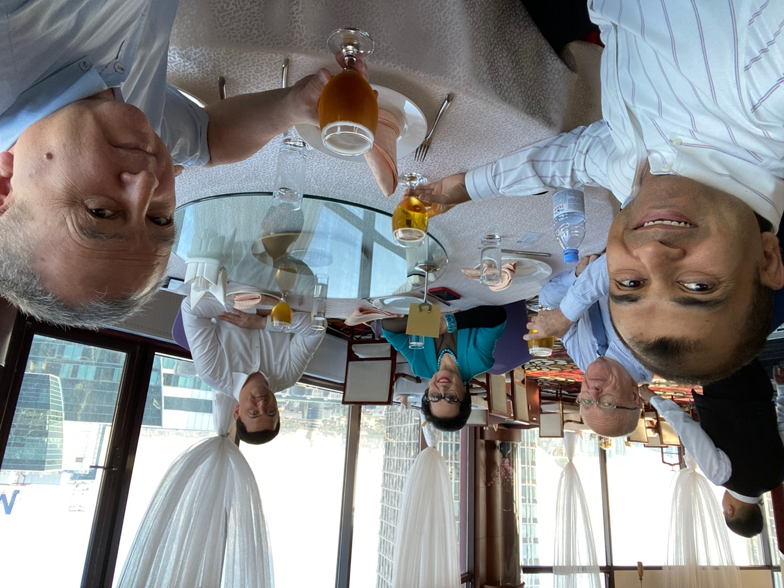

Beijing Hotel, the only high rise revolving restaurant with Dr. Nadyrov, Chancellor of Astana Medical University. True visionary, urologist by training.

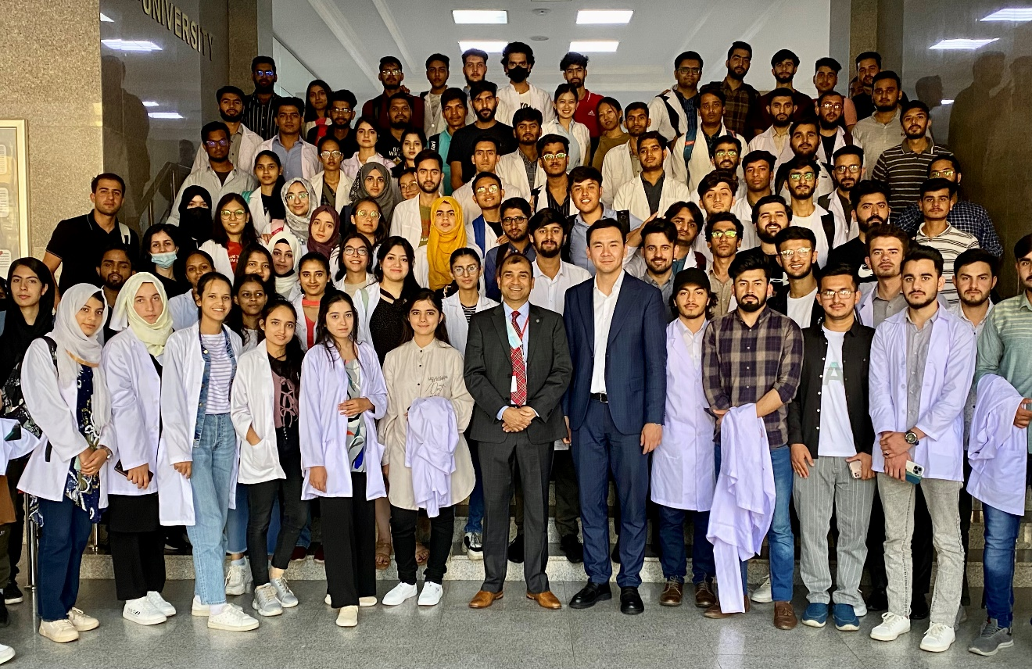

He asked me to give a motivational speech to the medical students the following day, Medical Students, Astana Medical University.

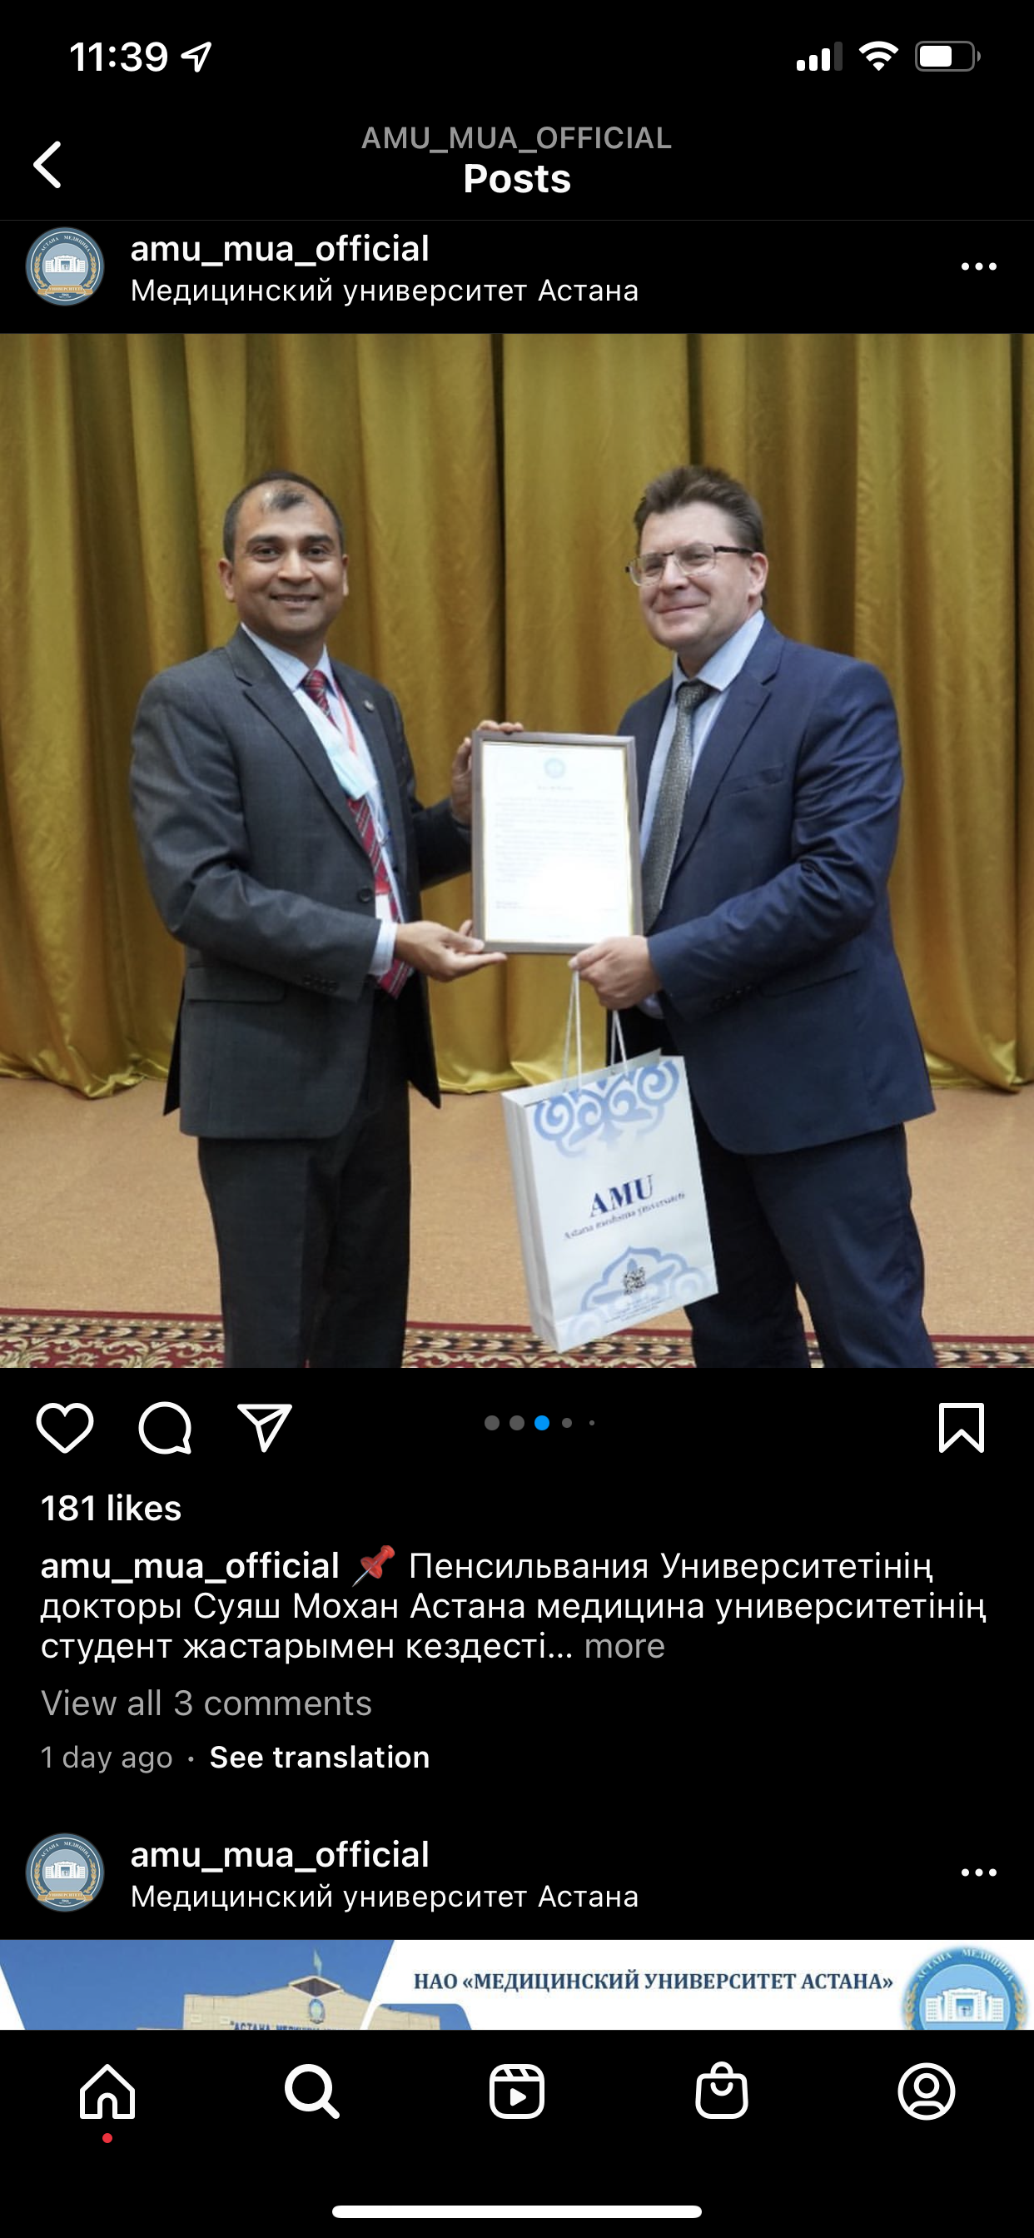

Vice Dean, AMU presenting a plaque. (This was posted on their website)

How are radiologists in Kazakhstan trained?
It is a 2-year residency after finishing 4 years of medical school and 2 years of internship. Also see above regarding need for restructuring radiology residency. Along the same lines I recommended to the dean of the medical school that the internship can be decreased to 1 year from 2 years, so effectively total training will only increase by one year but will offer a lot more specialized training that will be practical and is need of the hour. The alternative would be to decrease the internship from 2 to 1 year and increase residency training from 2 to 3 years with the third year reserved for 1 or 2 subspecialty mini fellowships.

How do the local medical professionals engage with RSNA? What is their overall impression of RSNA?
Local radiologists usually don’t attend the annual meeting for 2 main reasons, first is distance to Chicago which is far from central Asia, no direct flights and cost is also prohibitive for most local rads. The travel stipends can be very helpful, but most locals are not aware of this RSNA stipend. For example, there was an Uzbek radiologist who came to this ‘Astana Tutorial’ from Bishkek, Uzbekistan, said that in order to support his family he lectures at the medical school a few times in a week and I even saw the place where he was staying for the tutorial, it was a student’s hostel with ~$6/- nightly cost. He was eating in the subsidized hospital cafeteria where one can get breakfast for ~$2 and lunch for ~$3.
Their overall impression is good, but most have never been to the RSNA so they have no clear vision of how large of a meeting is this. How many educational, networking and learning opportunities are offered by RSNA, including educational journals, teaching cases, online lectures and tutorials and free memberships for trainees etc. I repeatedly encouraged all trainees to become members, reinforced with all of them that membership is free while they are in training and even for a few years after they finish training, and even told them about travel stipends, showed them the website and how to apply, as it will give them a lot of exposure to global radiology. WE need to follow up with these parent societies during our CIRE meetings so folks can take advantage of all what RSNA offers.

What is the local radiology society’s impression of RSNA?
Very similar to above. They are closer to the European Society of Radiology (ESR) and most people will travel to annual ECR meeting in Vienna. The other society that they are closely affiliated with is the AOSR. Then I found they also work closely with European Society of Cardiovascular Radiology (ESCR), for specialized training such as in Cardiac CT and cardiac MRI. There are some specific radiology courses offered by the ESOR, European School of Radiology, such as the Graz Tutorial https://www.esor.org/esor-graz-tutorial/
I met with Prof Rainmueller, department chair at Med Univ Graz, Austria, who was also one of the speakers at this Astana Tutorial and got a lot of insight into radiology and overall life/culture here in Central Asia, Russia as well as adjacent Europe. He has been visiting KZ every year since 2007 for teaching and training local rads. The other very impressive thing about him that he learned Russian at this age (when he was at the peak of his career) and is now fluent and gives lectures/PowerPoints in Russian/English/German and Austrian! Full of energy and enthusiasm for promoting radiology in underserved regions. Would be great to have him (if he is willing to travel) in one of our committees!
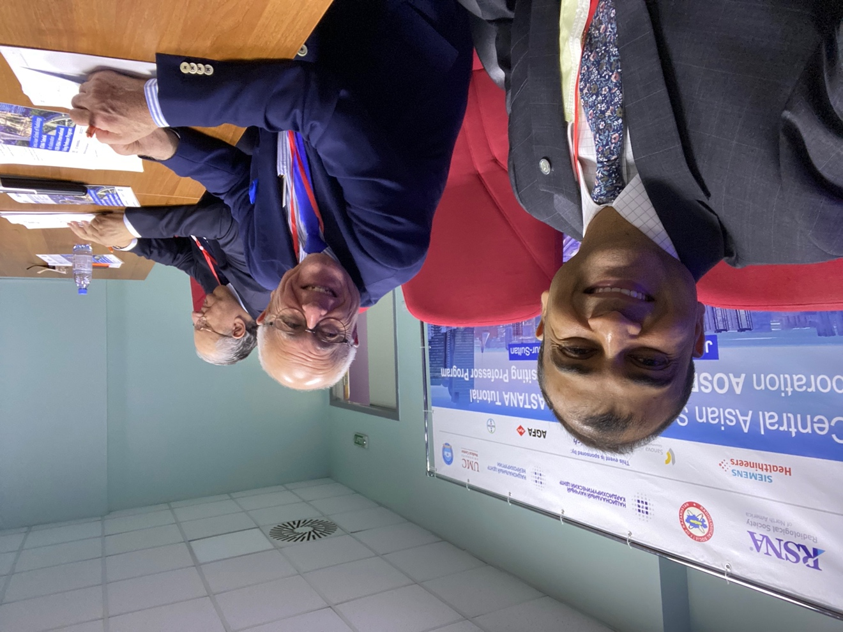
With the every bright and energetic Prof. Rainmueller

What is the dynamic between those in training and their superiors?
Extremely hierarchical!!
Despite of my training in India, I was very surprised and somewhat shocked to see this degree of hierarchy between the department heads and the trainees. The trainees will do all the work, create reports and then review everything with the attendings before the reports are finalized. The trainees are not allowed to leave until all the work is finished, they are at the front lines of all major hospitals and responsible for all clinical work! They will all stand up when the attending walks in, bend over to express respect (not quite like Japanese culture, but at least half of that :), shake hands with ‘both’ hands, offer their seat, some of which I think is typical for many Asian countries, but the cultural change was striking. Despite of this I found some trainees to be very smart and navigate this superiority gradient appropriately in a manner that was very productive and non-confronting.

What is the relationship between the host society and the local institutions/hospitals?
The Kazakh Society of Radiology (KSR) was established soon after their independence from USSR, by a visionary in the country, Prof. Zhangali Hamzabaev, who is respected and known as the ‘father of radiology’ in the country. He single handedly led the training of radiologists and was a devoted teacher and an outstanding radiologist and is universally remembered and respected by everyone. He was also the founding president of Kazakh Society of Radiology. He recently passed away in 2014 and since then his wife Prof. Raushan Rakhmzanova became the next president (see photo). She is also a very powerful woman with tremendous energy and enthusiasm even at the age of 83 years, for teaching and training the next generation of radiologists, see photo. I was super impressed by one of her talks on ‘advances in breast imaging’ where she delivered a very comprehensive talk, with full energy for one full hour and covered topics ranging from film-based mammography, to digital tomosynthesis, PET-CT, PET-MR, newer radiotracers to even AI! Impressive!!
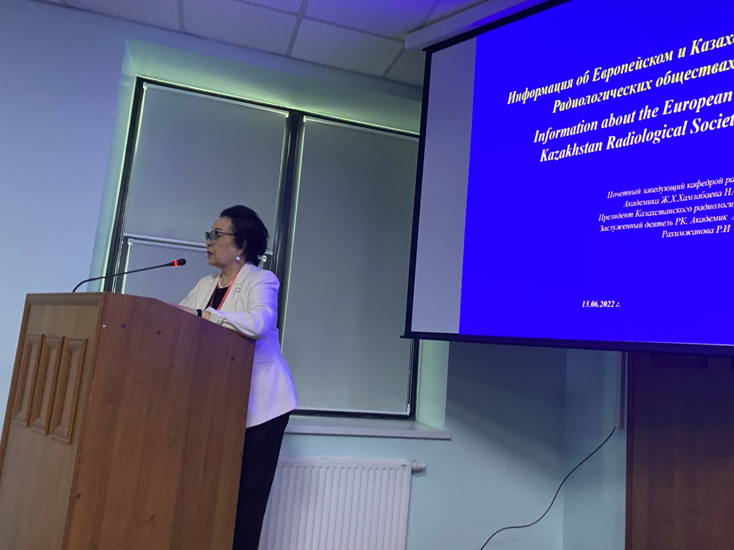
Prof. Raushan Rakhmzanova, President, Kazakh Society of Radiology.
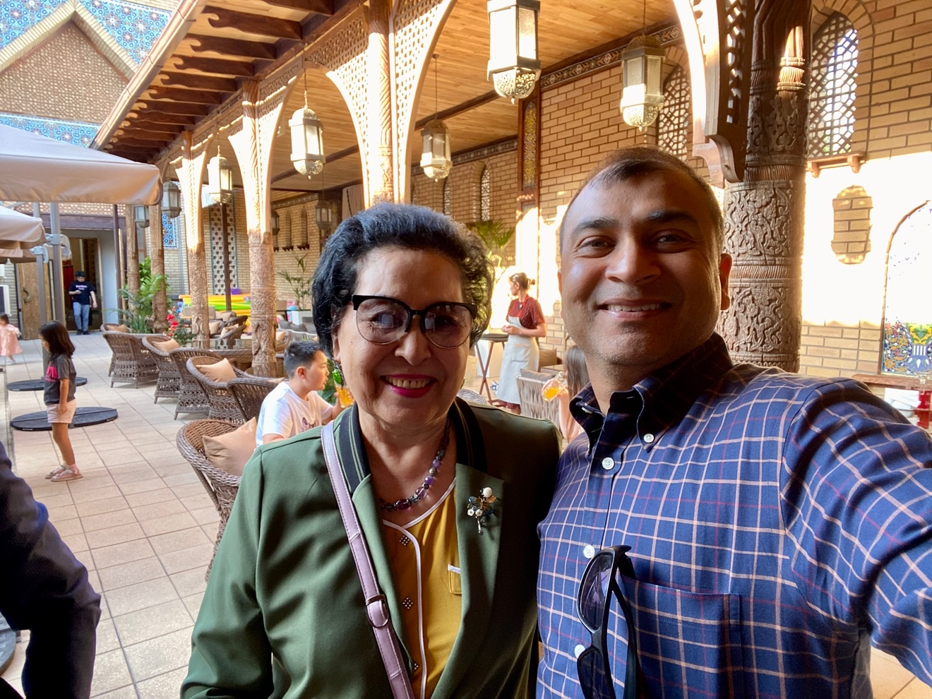
Prof. Raushan Rakhmzanova – Very bright and always full of energy
The current vice president of the society is Prof. Tairkhan Dautov, (our liaison) who is also a committed, devoted teacher and is trying his level best to elevate the overall status of training provided in KZ by organizing this 2-week Astana Tutorial every year which this year was offered in association with AOSR, ESOR and RSNA-IVP program. He is the point person coordinating the participation of KZ society with international organizations as well as with local hospitals and institutions.
In summary, the relationship is very healthy and forward looking with visionary leaders who are trying their level best to lift the standing of the practice of radiology and overall entire medical care throughout the central Asian region. Collaborative efforts from RSNA and other Asian-Oceanic and European societies is highly appreciated!
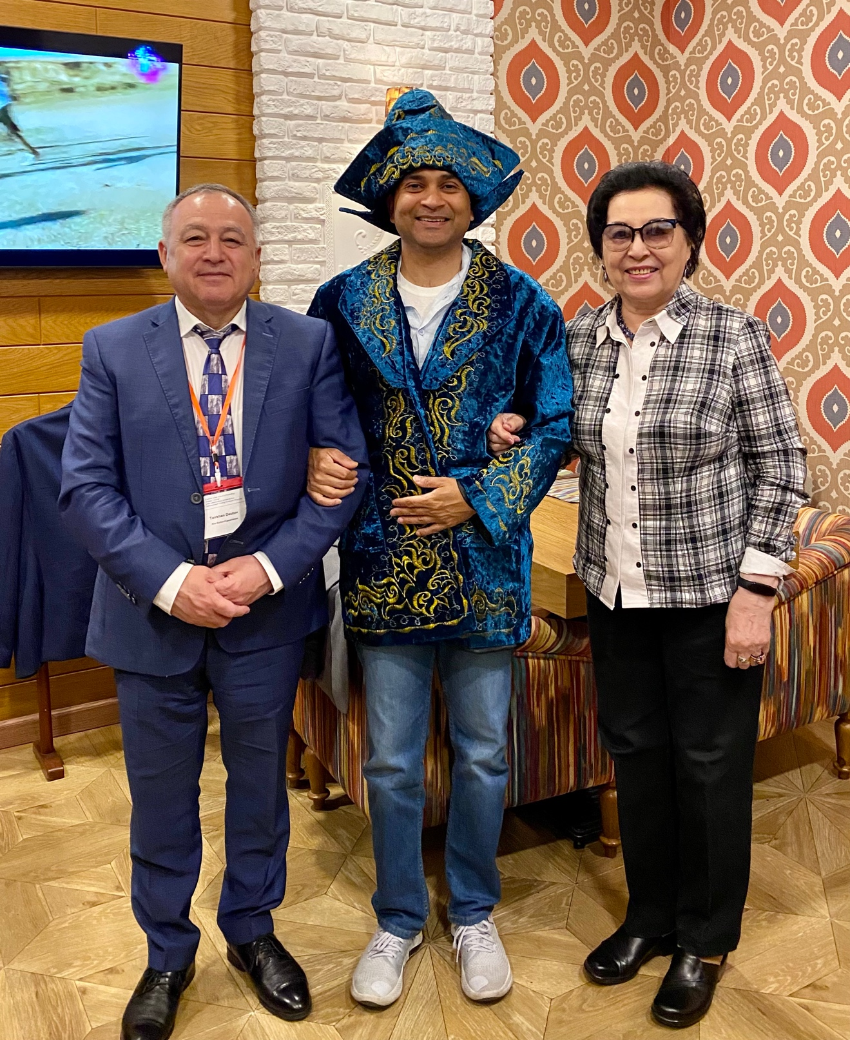
Traditional Kazakh dress on behalf of the KSR
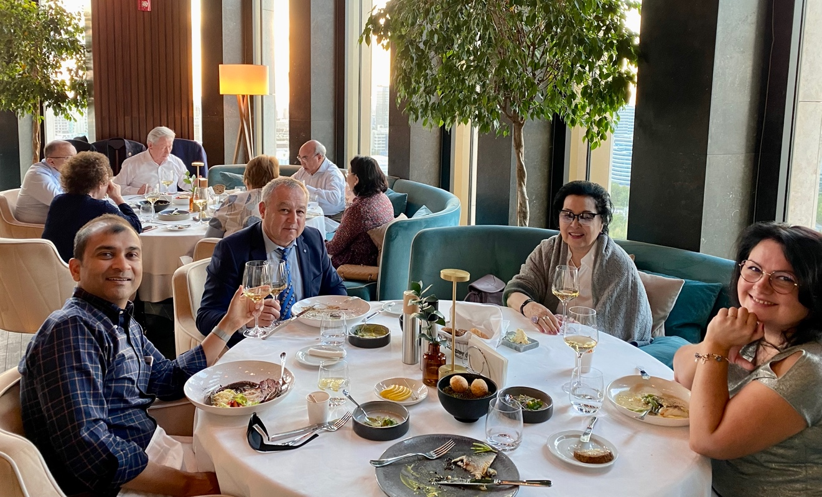
One of the vendor sponsored dinners (President of Kyrgyzstan in the background).

What areas of education were of most interest to:

Radiologists (faculty):
- Senior attending radiologists were most interested in getting their protocols updated across different scanners at their major hospitals, which I did across all major hospitals.
- They asked me to provide reporting templates for common neuroradiological diagnoses, which I did.
- They asked me to review difficult cases/diagnostic dilemmas, some recent/live cases and some difficult cases from their archives.
- They asked to me review medico-legal cases and asked me how I would have interpreted the exams and what would be my opinion if I was the expert on that case. Overall very productive 2 weeks.

Residents/Fellows:
- Trainees and some junior attendings were most interested in learning about specific topics such as neurotrauma, emergencies, CNS infections and algorithmic approach to a brain mass, to name a few.
- They wanted me to show them how we teach radiology trainees here in US.
- They wanted me to do a resident “hot-seat” type conference trying to simulate a viva-voce type of examination (similar to our oral boards).
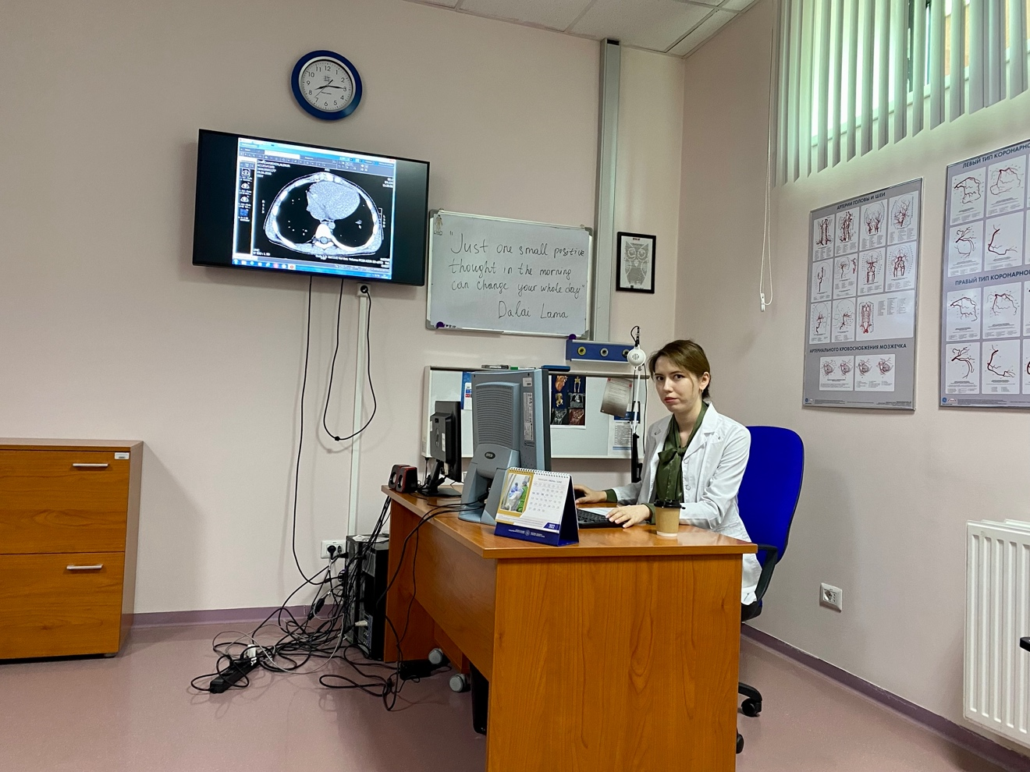
One of their residents presenting morning conference.
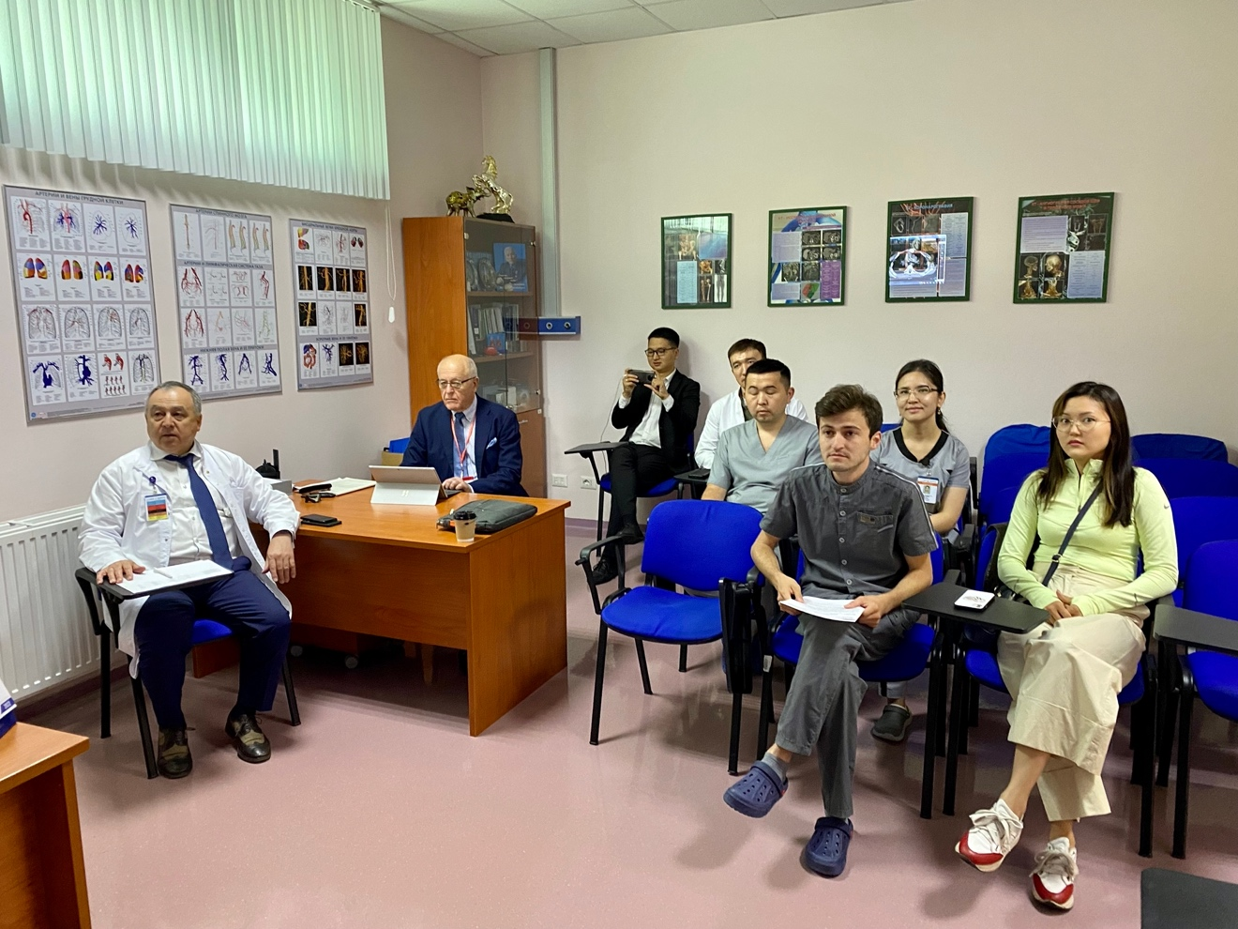
The other side of the conference room

Other(s) – if applicable:
Overall, I gave the following didactic lectures:
- ‘Basic Neuroanatomy: Practical Applications’,
- ‘Central skull base: Anatomy (normal variants) & Pathology’
- ‘Maxillofacial trauma: Practical Tips’
- ‘Neck Pain: Acute and deep space infections’
- ‘Imaging the found down patient: Where and how Radiology makes a difference?’
- ‘Brain Pain: CNS infections and COVID-19’
- ‘Adult brain tumors: An Algorithmic Approach’
- ‘Infratentorial tumors: Differential diagnosis by location’
- ‘Post-Therapy Assessment of Brain Tumors: An Ever Evolving Landscape’

I did the following workshops:

How to approach C spine trauma

How to assess a sellar mass

Approach to an epileptic patient

Hands on workshop on practical DTI and fiber tractography

Hands on workshop on practical aspects of MR Spectroscopy

Hands on workshop on perfusion and permeability imaging

Approach to the TMJ

How to approach a new brain mass?

I did workstation training at all of their major hospitals
Special sessions:

Protocol updates

Technologist education

MRI Quality and safety seminar/tutorial

Did you feel other areas of medical education would be of greater benefit/more appropriate for the groups above? If so, please explain.

Radiologists (faculty):
Teach the teachers, so they can in turn teach the trainees!
There are several areas in radiology that can be of benefit, such as stroke imaging, neurointerventional techniques, coordinating a multidisciplinary course/meeting for conditions such as epilepsy, head and neck cancer, brain tumors, pediatric meuroradiology etc.
Other areas of medical education that will be beneficial would be in neurology, specifically, neurodegenerative disorders, child neurology, advanced in functional neurosurgery etc.
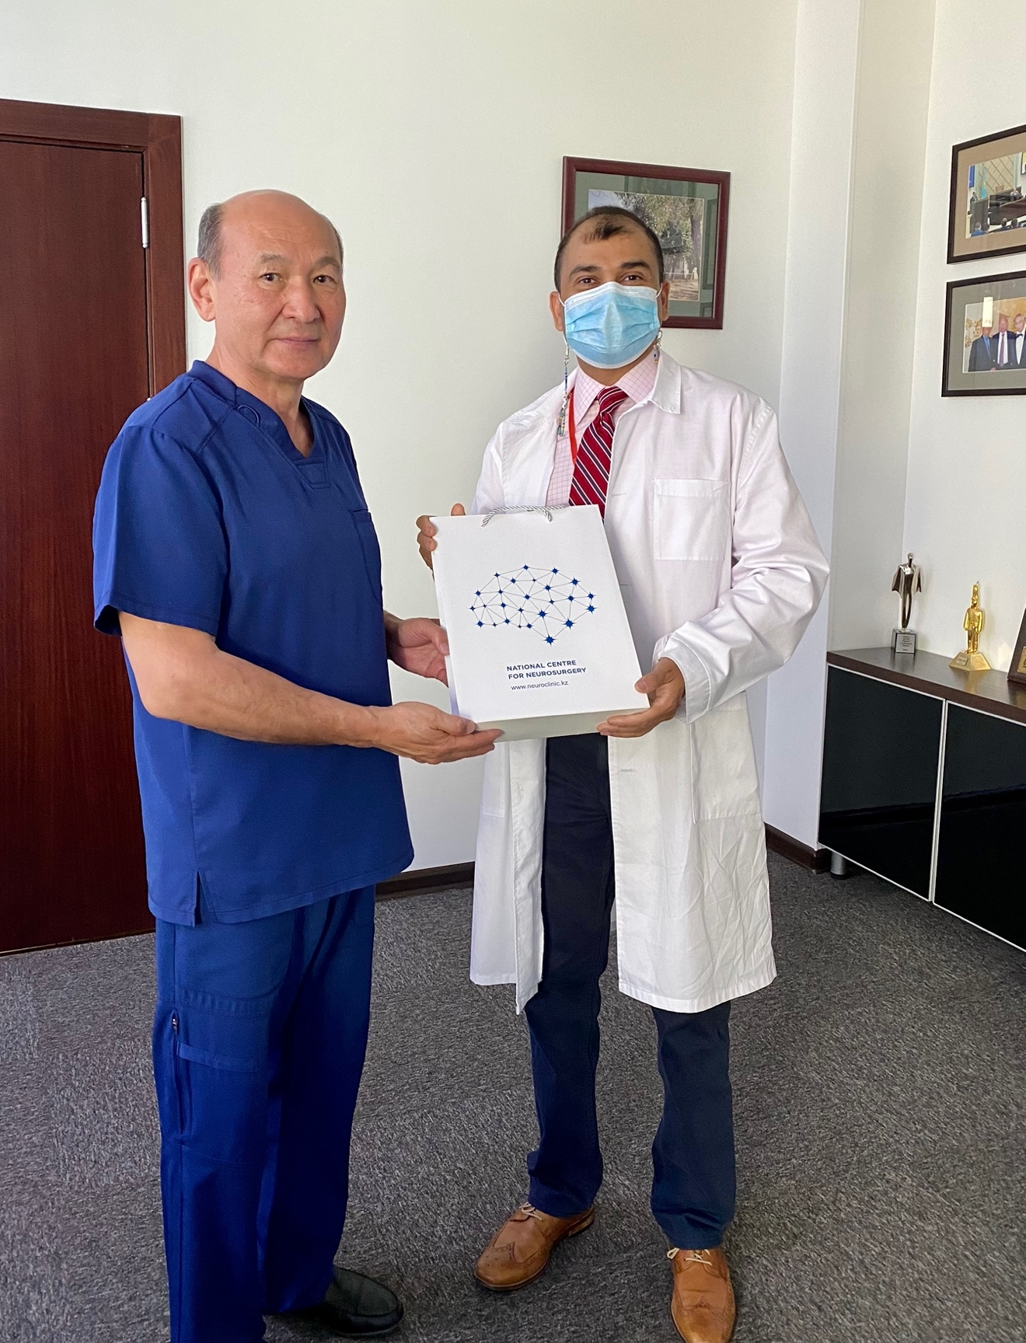
With the overall director of the National Neurosurgery Center, chair of Neurosurgery

Residents/Fellows:

Encourage them to attend international meetings like RSNA which will provide a lot of exposure and as mentioned above travel stipends can be very effective.
Providing opportunities for visiting observer-ships at leading academic institutions in US. Along the same lines, I am very happy to report that I am in touch with at least 5 of the local residents and junior attendings and one of them is already accepted for one such short term observer-ship position at UPMC, Pittsburgh, PA. Two others are in the process of coming over to my institution University of Pennsylvania.
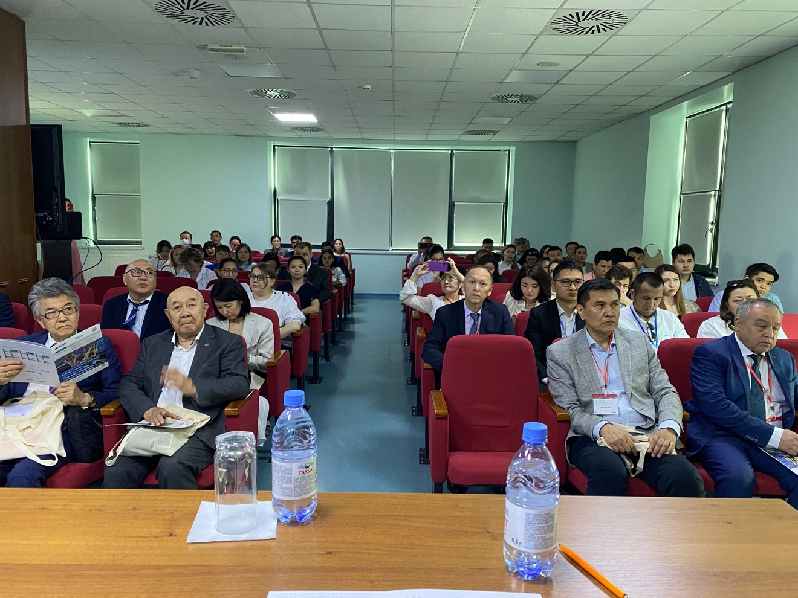
Lecture Hall

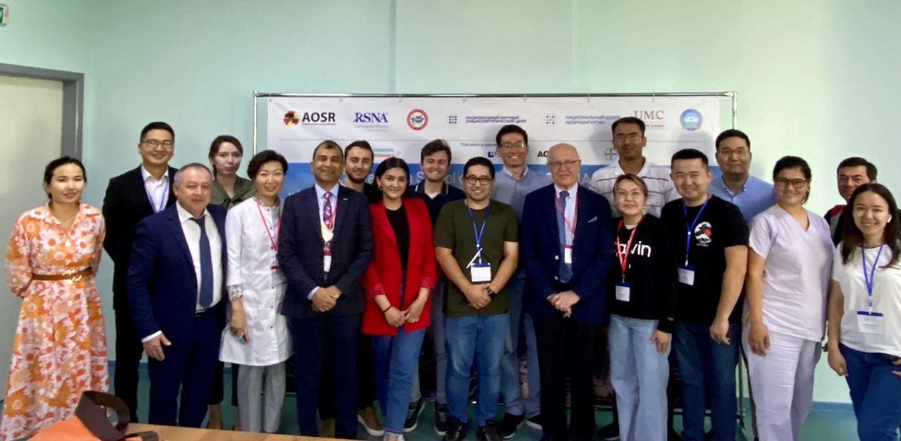

Group photograph on of the days

Other(s) – if applicable:
It is a resource poor (from the POV of expert/subspecialty trained doctors) country and would benefit from such visiting professorships from time to time. Medicine is an ever-evolving science, what’s current practice today may not be applicable or might change in future with new knowledge, new research, new/er treatments etc. Hence, I feel we should also consider teaching them research methods, so they are able to research important questions relevant to their society and medical practice.

What types of services would the local radiologists (including residents and fellows) benefit from?
See above - this has been covered in answers to questions above.

Was there anyone on your trip (regardless of professional level) that:

Stood out to you, why?
Yes, there were several very interesting stories:

Ultrasound doctor from Mongolia that I mentioned above that had to work as a chef in Dubai, difficulty in getting a medical license in UAE.

The mother of one of the residents runs an ultrasound clinic in rural KZ and makes much more than several other docs in that region, only does fetal US, and her clinic starts early in the morning goes on till midnight.
The people of this country are AMAZING, their warmth and welcoming nature is something that must be experienced in person.
The capital city Nur Sultan and its architecture, buildings, monuments are very modern, overall infrastructure is new, lots of real estate developments are visible all over, with nice big malls, multi-ethnic culture and restaurants add icing to the cake!
See photos.
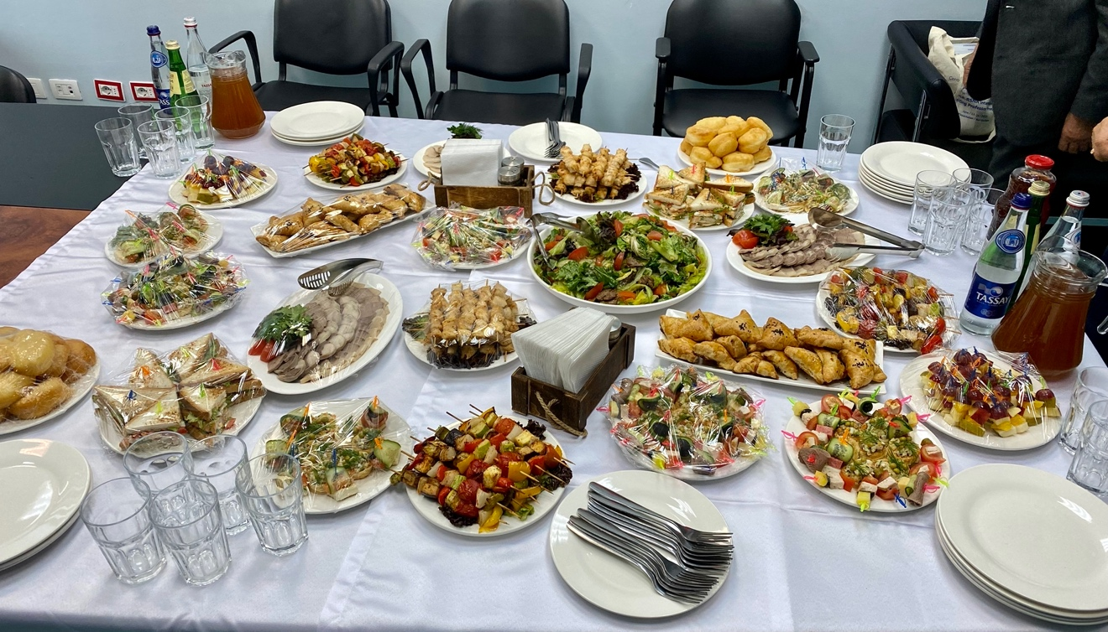
Just one example of the kind of spread which was offered almost every day after the lectures
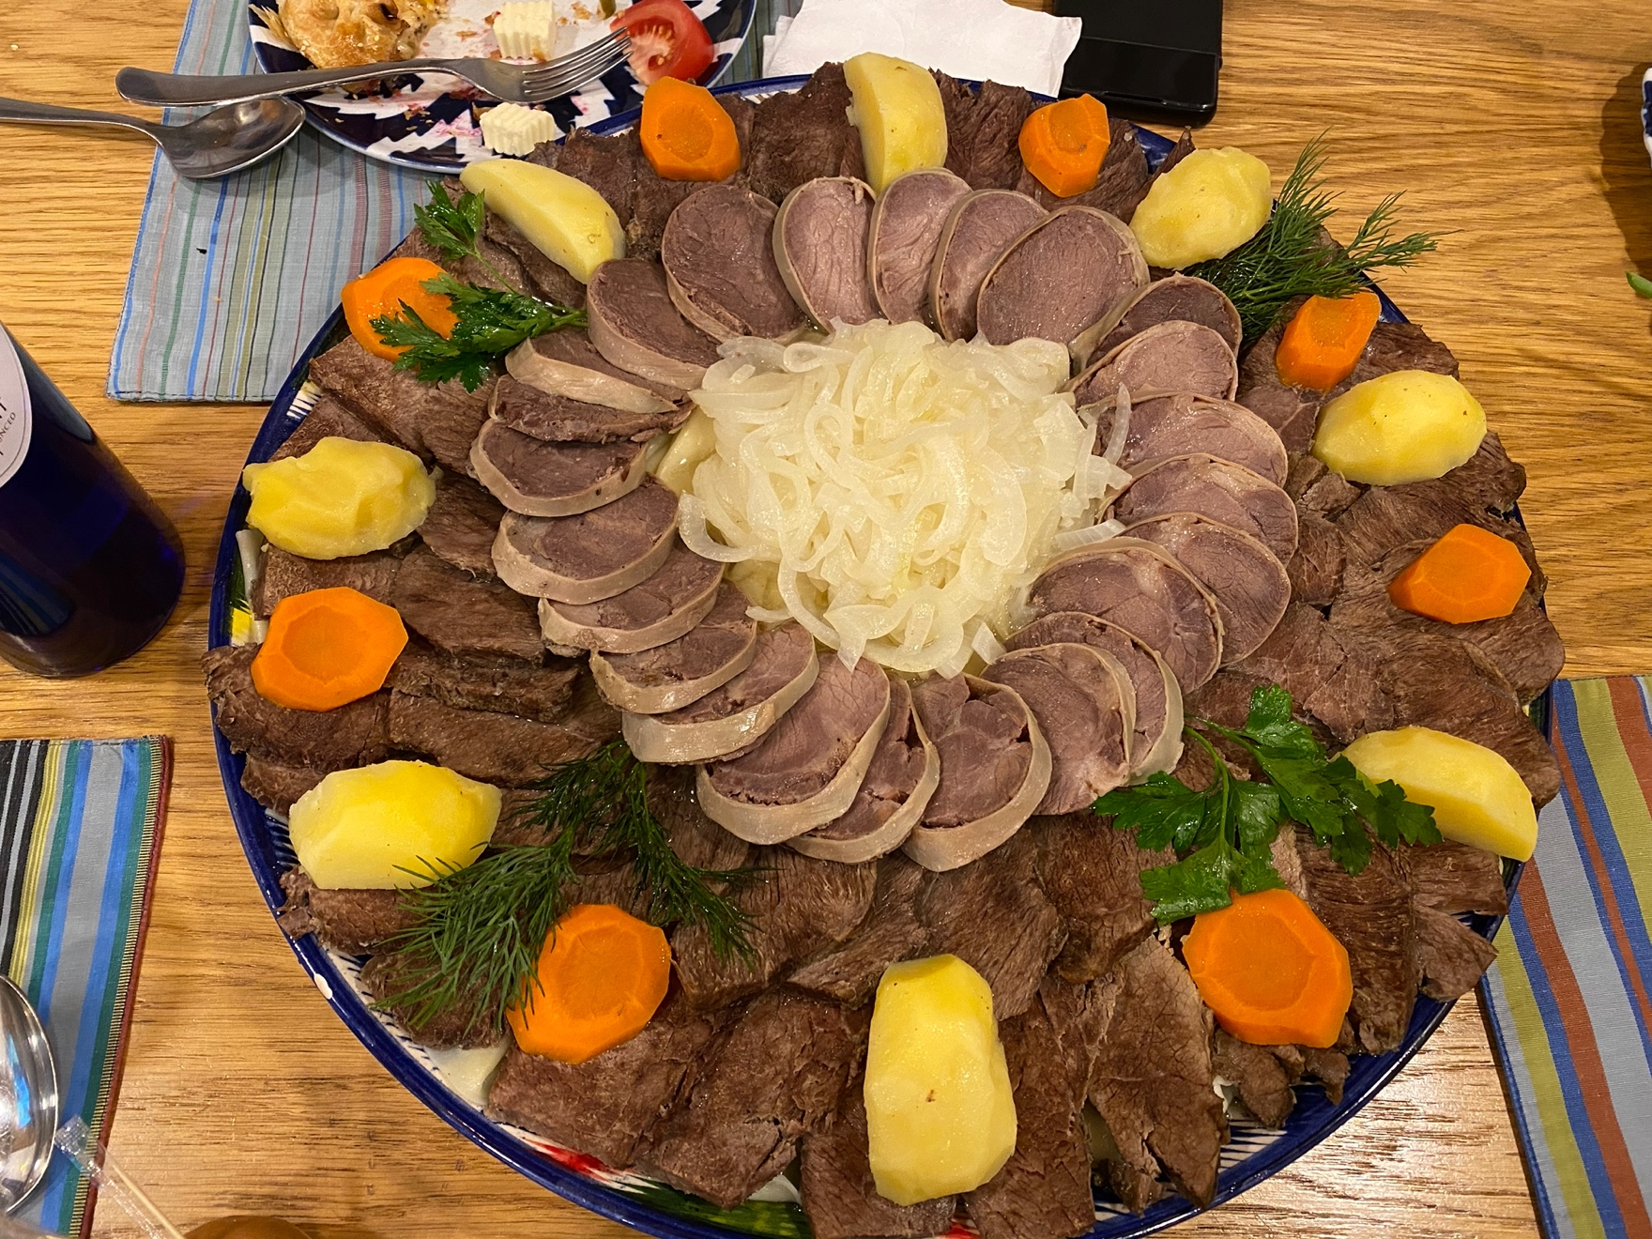
Beshbarmak, national dish, all horse meat!
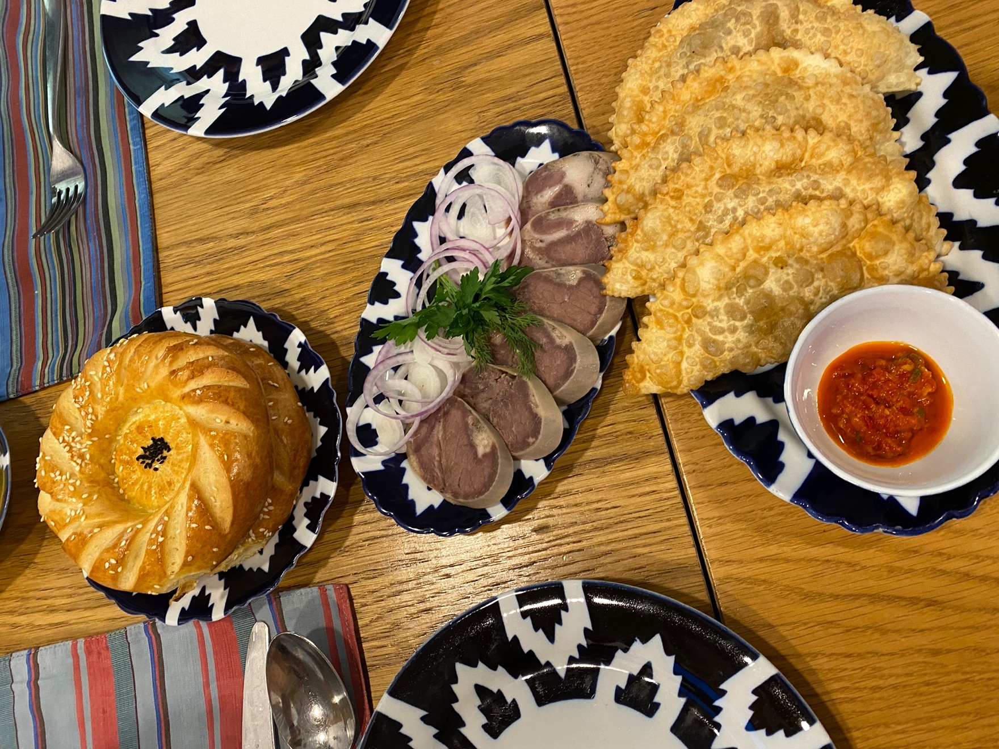
They lobe their bread and it is always fresh and delicious! Notice, horse meat sausage in the middle!

Describe the technology available:

At the radiology meeting:
Very basic technology was available in the actual auditorium where most formal lectures were delivered. They had a projector which was connected to a basic laptop with zoom and screensharing capabilities. There was no dedicated AV suite or AV department/personnel, and a few tech savvy residents were running the entire show for full two weeks.
There was a podium on the stage with a microphone and a wireless slide advancer laser pointer which was used during lectures.

At the local institutions/hospitals:
As expected, most of the advanced neuroradiology work was performed on the scanner itself and on an AW workstation, right next to the scanner (see photos). There was no dedicated 3D lab or trained super techs who would do the advanced post processing for newer neuroradiology sequences.
Surprisingly, the equipment I saw in terms of US machines, CT scanners and MRI machines were all state of the art. They gad a 256 slice CT scanner (see photo above), 3Tesla MRI (see photo above), and even a PET scanner.
I was very impressed to see that they recently acquired gamma knife stereotactic radiosurgery which is the only one available in the entire region (see photo).

Personally, by the medical professionals (cell phones, iPads, etc.):
Most residents and attendings were using high tech devices such as apple iPhone. Mac devices such as laptops and iPads weren’t that common.
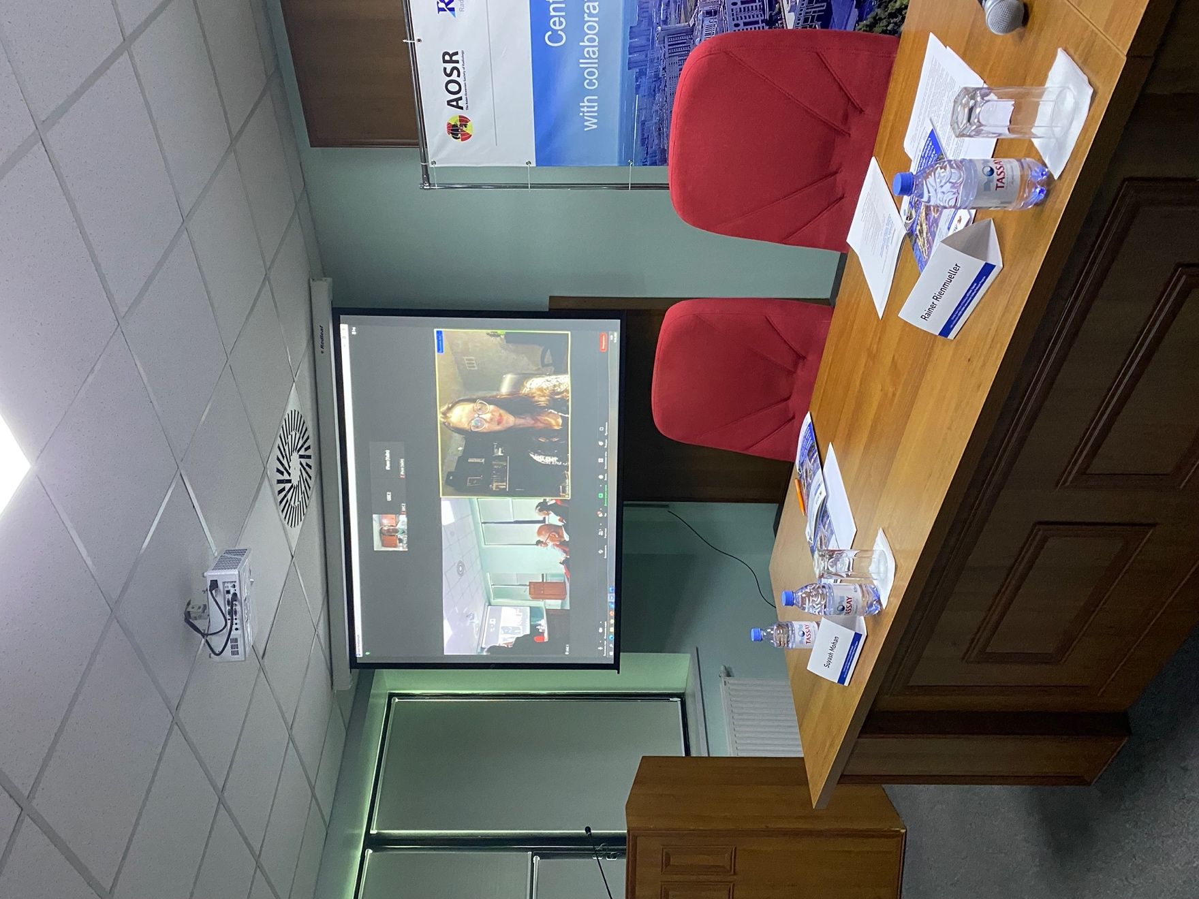
Dr. Souza giving her talk and live Q and A

Where/how is continuing education consumed by:

Radiologists and residents:

Continuing medical education is a part of every radiologist's professional growth and development which helps in keeping up to date with newer techniques and advancements. I am not certain of certain number of CME credits were required for maintenance of certification in KZ as there was no CME which was offered for these 2 weeklong courses.

It is however clear to the local radiologists that attending educational meetings as well as constantly reviewing current teaching materials will help them in improving their performance and eventual quality of patient care in their region.

I found most continuing activities were self-directed, often suggested by the supervisors and mostly consisted of available online videos and lectures.

What were the most frequently asked non-medical questions?

Oh, you have never eaten horse meat?

Oh, you have never tried horse milk?

Oh, you have never tried camel milk?

When will you come back? I think the visit was extremely successful at so many levels, personally, professionally as well as emotionally.

It’s your toast now! Local Kazakh culture has tremendous influence from the Russian culture which includes alcohol in various forms. I ended up toasting 3-5 times every night during their formal dinners. It was fun, mastered a new art of toasting, to the point that I started volunteering, “it’s my toast now”… in the last few days of my visit .

What do you think of the Kazakh people/culture? They asked this question all the time trying to get a sense of how foreigners perceive their people and their culture.

What will you eat/drink! The hospitality in this country is unbelievable. One must visit to be able to experience it! Highly recommended.

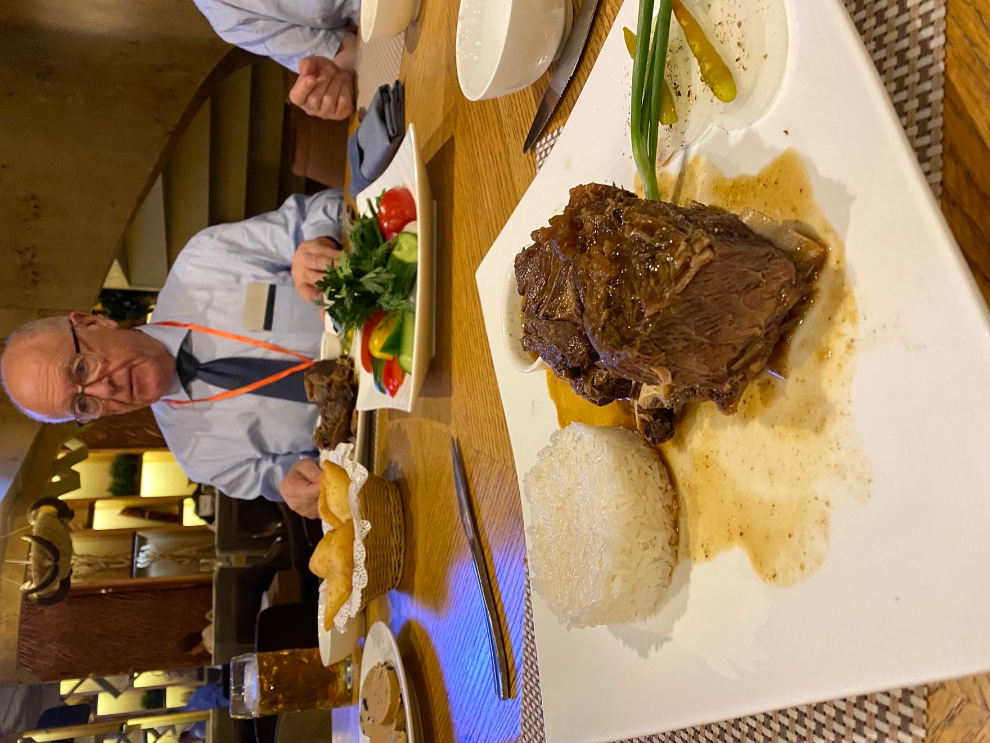

They served horse meat faculty dinner in their national restaurant. Note fresh camel milk on the side in white bowl.

I will be most delighted to help, support, plan and even organize a trip for the RSNA for other IVPs

I am extremely grateful to the Radiological Society of North America (RSNA), Meaghan, Meredith and the entire team for organizing and facilitating this incredible international visiting professorship to promote radiology and neuroradiology throughout the world.

This unique and highly rewarding experience will remain as one of my most cherished memories as a radiologist. I recommend a trip to Kazakhstan to all my friends and colleagues and wish everyone can experience this amazing country, unique culture and above all the ‘warmth’ of the Kazakh people.

Hospitality is considered to be a sacred duty in Kazakh society. It is like a tradition, their national character, and locals say, “meet a guest as the God's messenger”, and this was clearly evident in every walk of life that I experienced in my two weeks there.
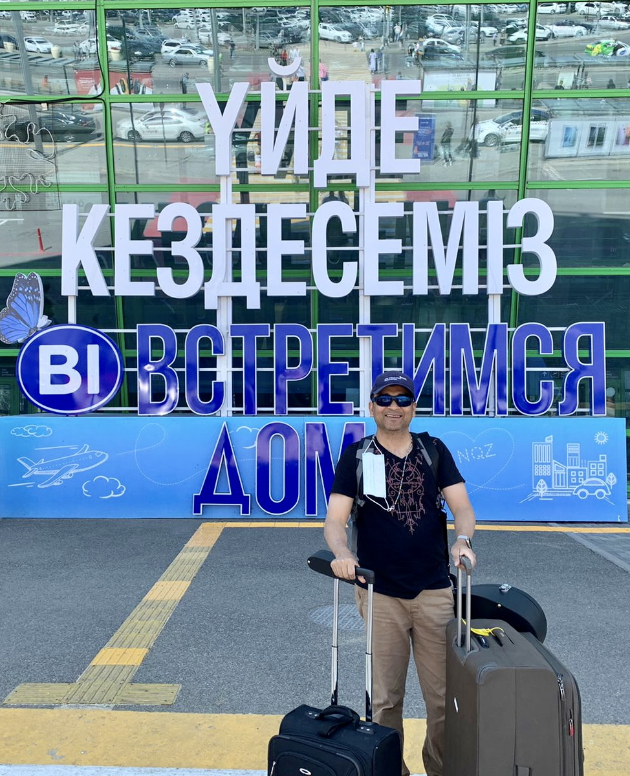
On my way back after an amazing 2 weeks in Kazakhstan

I would also like to take this opportunity to thank Dr. Laurie Loevner, Chief of Neuroradiology here at Penn for her mentorship and our Department Chair Dr. Mitchell Schnall for giving me the time and allowing me to represent Penn Radiology in Central Asia.

My gratitude also goes, most of all, to my most welcoming and gracious Kazakh hosts.

With sincere regards.

Suyash Mohan

